Project Documentation: PhenoAI
Project Name: Pheno Predictor (PhenoAI) Type:

1. Executive Summary
PhenoAI is a machine learning system designed to predict the 100-Grain Weight (GRWT100) of rice plants. This metric is a crucial indicator of crop yield potential. The system allows researchers to input biological data (DNA sequences or morphological traits) and receive immediate predictions via an API or asynchronous email reports for large datasets.
2. System Architecture
The project is built as a Distributed System to handle heavy computational loads without freezing. It separates the "User Interface" from the "Processing Brain."
Core Components:
- The Client (User): Submits data via a web interface or API.
- The Broker (Redis): Acts as a message queue. It holds tasks in line until a worker is free.
- The Worker (Celery): A background process that picks up tasks, runs the AI calculations, and handles file processing (Zipping/Emailing).
- The Brain (PyTorch): The deep learning framework that executes the prediction models.

3. File & Directory Manifest
Below is a description of every file generated and used in this project:
A. Source Code
- tasks.py: The core engine of the system.
  - Role: Defines the Celery application and worker tasks.
  - Key Functions: predict_lite_task (for single inputs), process_csv_task (for batch CSVs), and send_email_with_zip.
  - Logic: Handles data scaling, model lazy-loading, prediction, file compression, and SMTP email delivery.
- docker-compose.yml: The orchestration file.
  - Role: Defines how to run the services (Redis container and Worker container) together. It ensures they share the same network.
- Dockerfile: The blueprint for the environment.
  - Role: Tells the computer what to install (Python 3.9, PyTorch, Pandas, Celery) to make the code run on any machine.
- requirements.txt: The dependency list.
  - Role: Lists libraries like torch, pandas, celery, redis, and scikit-learn.
B. AI Models & Data
- lite_model.pth: The "Speed" Model.
  - Description: A lightweight Neural Network optimized for single-sample prediction. It accepts 10 features.
- best_model.pth (Heavy Model): The "Accuracy" Model.
  - Description: A robust Neural Network trained on the full dataset. It handles complex batch processing.
- lite_scaler.pkl: The Normalizer.
  - Description: A saved Scikit-Learn object that remembers the math (Mean and Variance) used during training. It ensures new inputs are scaled exactly like the training data.
- merged_rice_data.csv: The Reference Data.
  - Description: The original training dataset. Used by the worker to dynamically fit the scaler for heavy batch processing.

4. The Workflows (Process Description)
Process A: The "Lite" Prediction (Real-Time)
Used when a user wants to check one specific plant quickly.
- Input: User provides a list of values (e.g., ['A', 'T', 0.5, 1.2]).
- Mapping: The system converts DNA characters ('A', 'T') into numbers (1.0, 2.0).
- Scaling: The lite_scaler.pkl adjusts the numbers to fit the model's range.
- Inference: lite_model.pth calculates the weight.
- Output: Returns a JSON response (e.g., {"result": 2.45}).
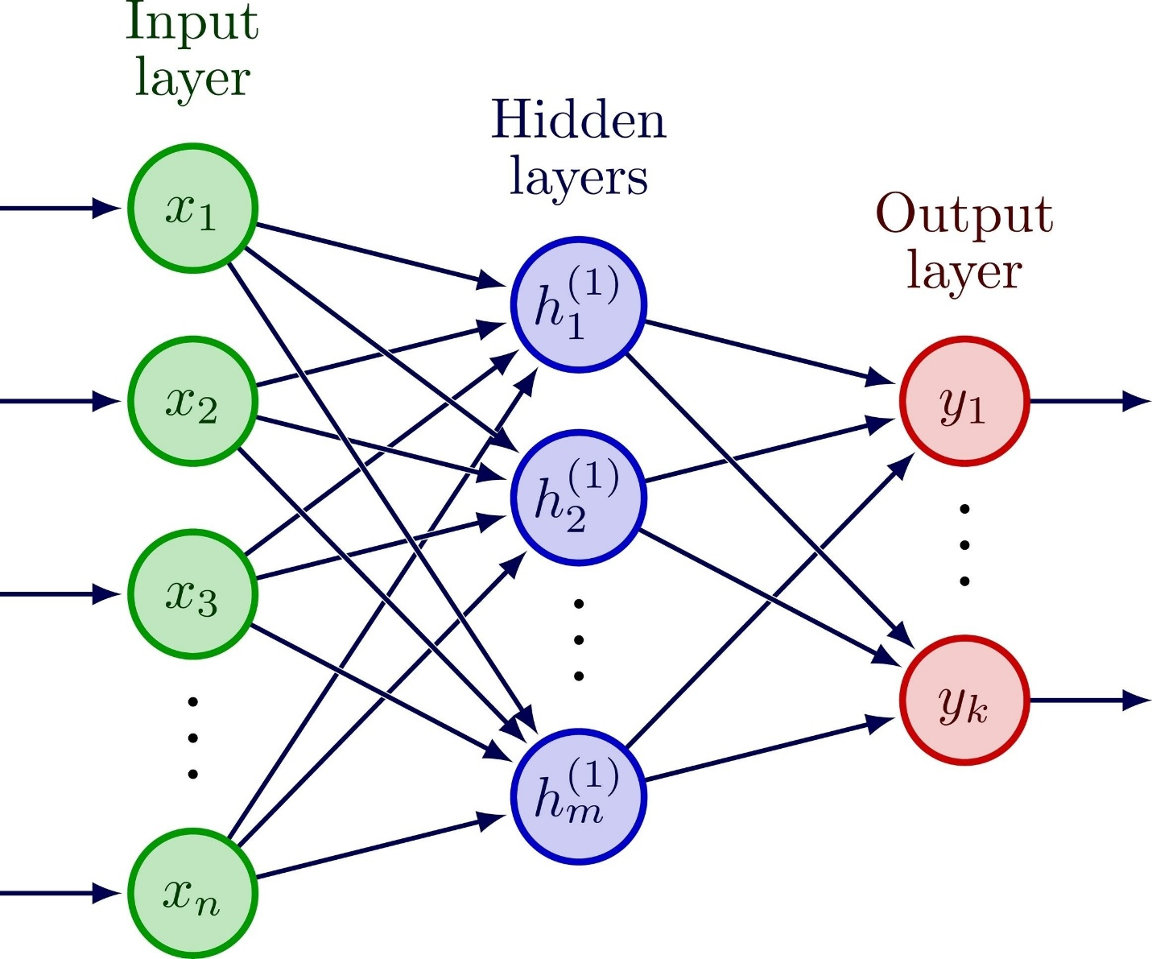
Shutterstock
Explore
Process B: The "Heavy" Prediction (Batch Processing)
Used when a user uploads a spreadsheet with thousands of samples.
- Upload: User uploads a .csv file.
- Queueing: The task is sent to Redis. The user gets a message: "Processing started."
- Processing (Background):
  - Celery Worker wakes up.
  - Loads merged_rice_data.csv to understand the data structure.
  - Scales the user's data.
  - Runs best_model.pth on all rows at once.
  - Appends a new column: Predicted_GRWT100.
- Optimization: The worker extracts only the ID and Prediction columns to create a lightweight result file.
- Compression: The file is Zipped (.zip) to bypass email size limits.
- Delivery: The system logs into Gmail and sends the Zip file to the user.

5. Technical Specifications
- Programming Language: Python 3.9
- Machine Learning Framework: PyTorch (Neural Networks)
- Data Processing: Pandas & NumPy
- Asynchronous Task Queue: Celery 5.x
- Message Broker: Redis 6+
- Containerization: Docker
Output Interpretation
The output value GRWT100 represents the weight of 100 grains of rice in grams.
- Typical Range: 1.5g to 3.5g
- Significance: Higher values indicate better yield potential.

